# **Network Automation**

* Automation can be used for:
* Device configuration
* Initial device provisioning
* Software version control
* Collecting statistics from devices
* Compliance verification
* Reports
* Troubleshooting

Which Automation Method to Use

* There are multiple methods that can be used to automate network management – Python scripts, NETCONF, RESTCONF, Ansible, Puppet, SDN, Cisco DNA Center etc.
* Not all methods are supported by all devices
* You should choose the method(s) which is most suitable for your environment and skills

# **Data Serialization**

* Data serialization is the process of converting structured data to a standardized format that allows sharing or storage of the data in a form that allows recovery of its original structure
* It allows transfer of the data between different systems, applications and programming languages
* XML, JSON and YAML are human and machine readable, plain text data encoding formats

# **API Application Programming Interfaces**

* An API is a way for a computer program to communicate directly with another computer program
* It is typically used to perform CRUD operations
* The two main types of APIs for web services (can run over the Internet, typically use HTTP) are SOAP and REST
* NETCONF and RESTCONF are APIs specifically designed to work with network devices

# **YANG Yet Another Next Generation**

* YANG (IETF, 2010) is a data modelling language which provides a standardized way to represent the operational and configuration data of a network device.
* It can be used both internally and when packaged for transmission.

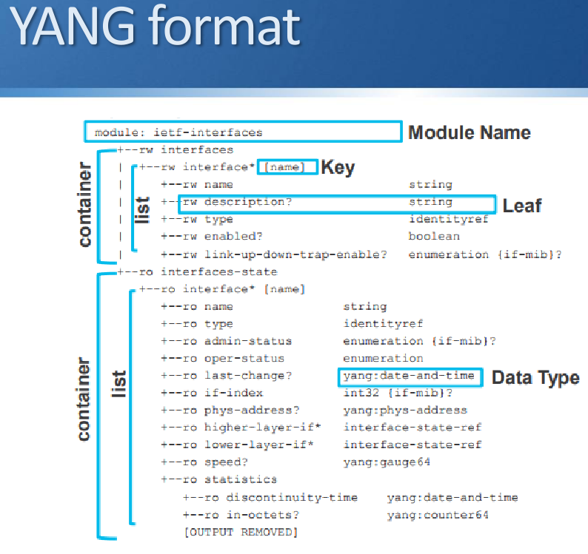

# **Network Management Transport**

* The configuration and operational status of a network device’s components and services can be remotely read or written to.
* NETCONF, RESTCONF and gRPC are APIs which describe the protocols and methods for transport of network management data.

# **Configuration Management Tools**

* Configuration management systems are designed to make controlling large numbers of devices easy for administrators and operations teams.
* They allow you to control many different systems in an automated way from one central location.
* Popular options (open source and free, with paid for Enterprise editions available):
  + Ansible
  + Puppet
  + Chef

# **SDN**

## **Router and Switch Planes**

* Data (Forwarding) Plane: Traffic which is forwarded through the device.
* Control Plane: Makes decisions about how to forward traffic. Control plane packets such as routing protocol or spanning tree updates are destined to or locally originated on the device itself.
* Management Plane: The device is configured and monitored in the management plane. For example at the CLI through Telnet or SSH, via a GUI using HTTPS, or via SNMP or an API (Application Programming Interface).

## **SDN - Data and Control Plane Separation**

* Network infrastructure devices are responsible for their own individual control and data planes in a traditional environment.
* Software Defined Networking decouples the data and control planes.
* The network infrastructure devices are still responsible for forwarding traffic, but the control plane moves to a centralised SDN controller.
* Rules for packet handling are sent to the network infrastructure devices from the controller.
* The network infrastructure devices query the controller for guidance as needed, and provide it with information about traffic they are handling.

## **Pure vs Hybrid SDN**

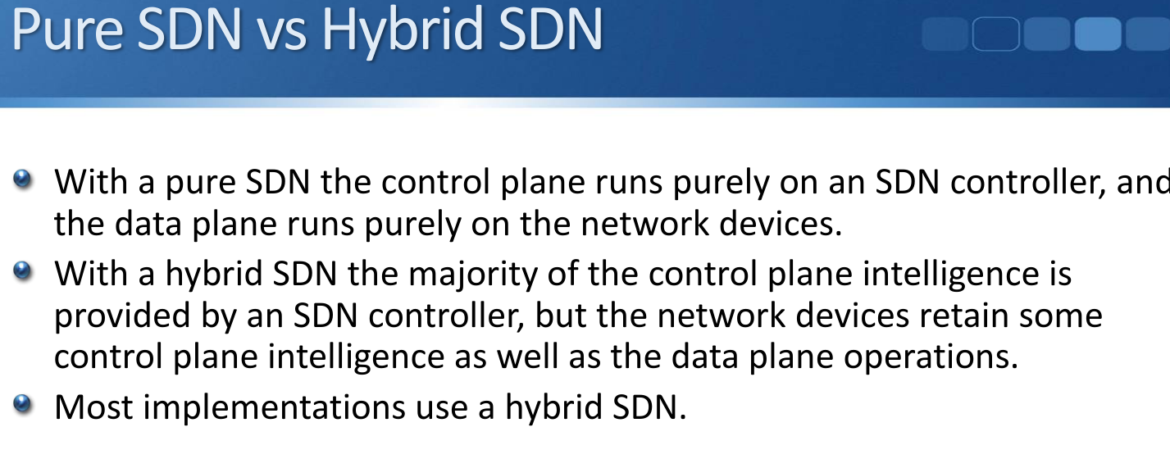

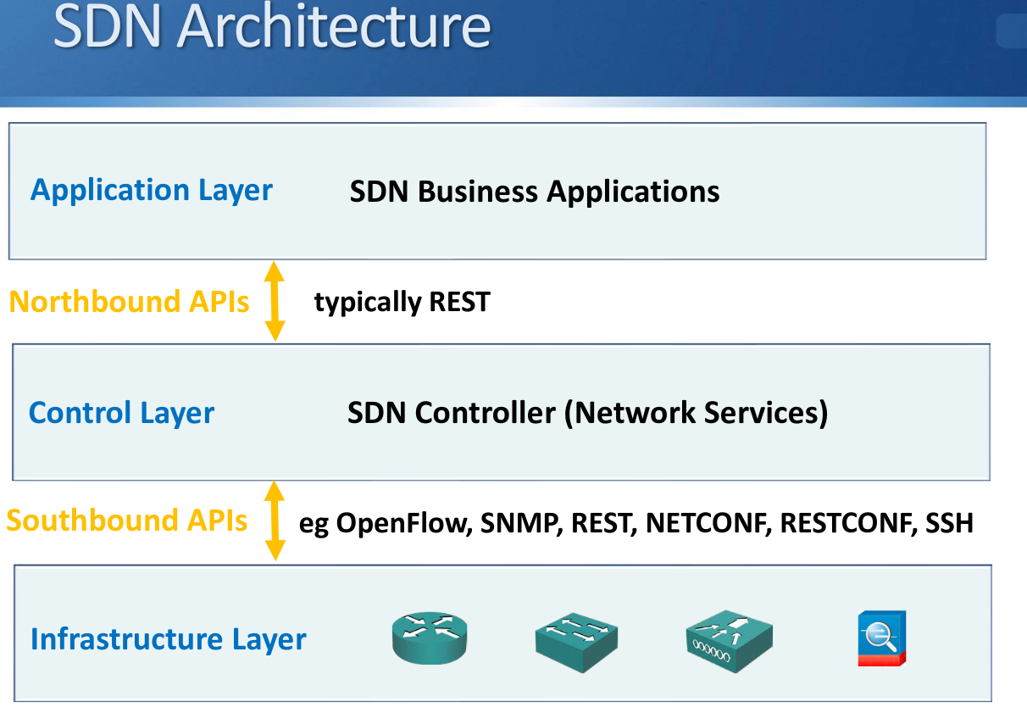

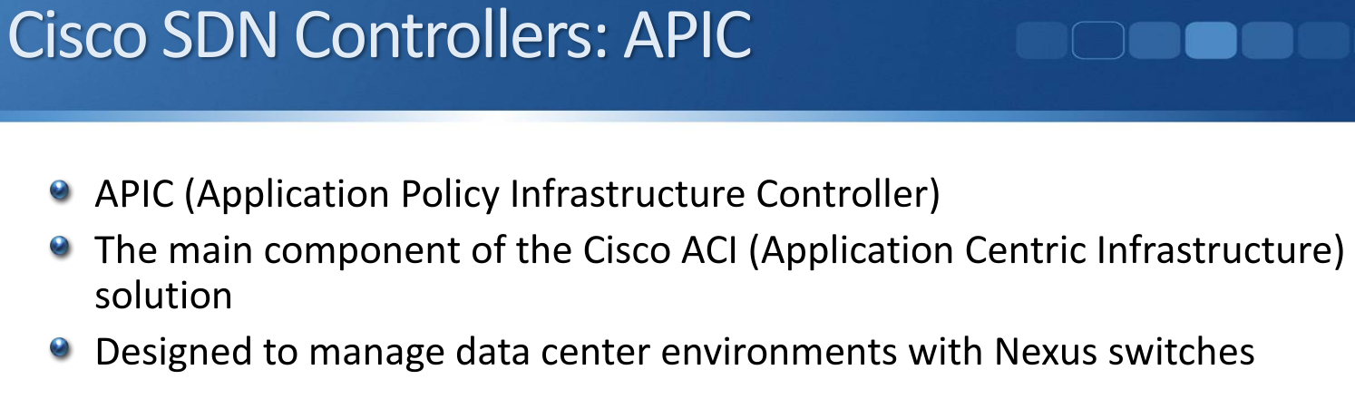

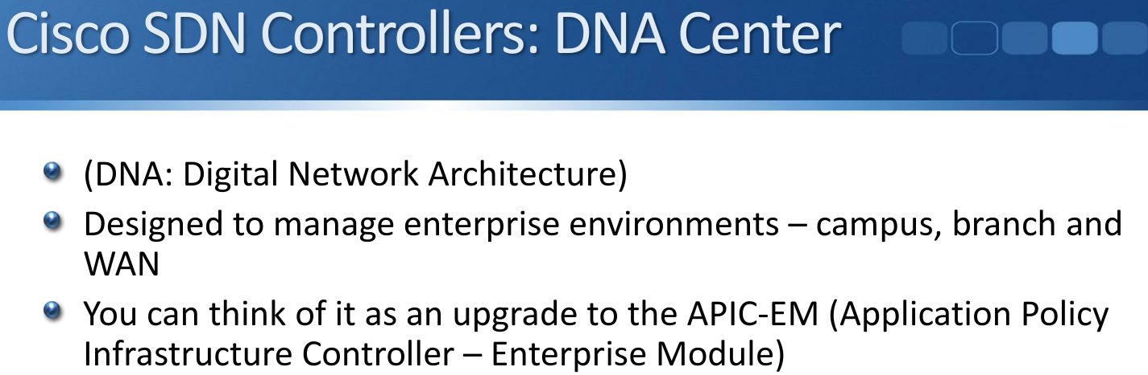

# **Cisco DNA Digital Network Architecture**

* “Cisco DNA enables you to streamline operations and facilitate IT and business innovation.
* Intent-based networking (IBN) built on Cisco DNA takes a software-delivered approach to automating and assuring services across your WAN and your campus and branch networks.”

3 of the main building blocks of Cisco DNA and Software Defined

Architecture are:

* DNA Center
* SD-Access
* SD-WAN

## **DNA Center**

* DNA Center is a Cisco SDN controller which is designed to manage enterprise environments – campus, branch and WAN
* (As opposed to the APIC which manages data center environments with Nexus switches)
* You can think of DNA Center as an upgrade to the APIC-EM (Application Policy Infrastructure Controller – Enterprise Module

## **IBN Intent Based Networking (IBN)**

* Intent Based Networking transforms a traditional manual network into a controller led network that translates the business needs into policies that can be automated and applied consistently across the network.
* The goal is to continuously monitor and adjust network performance to help assure desired business outcomes.

## **UI**

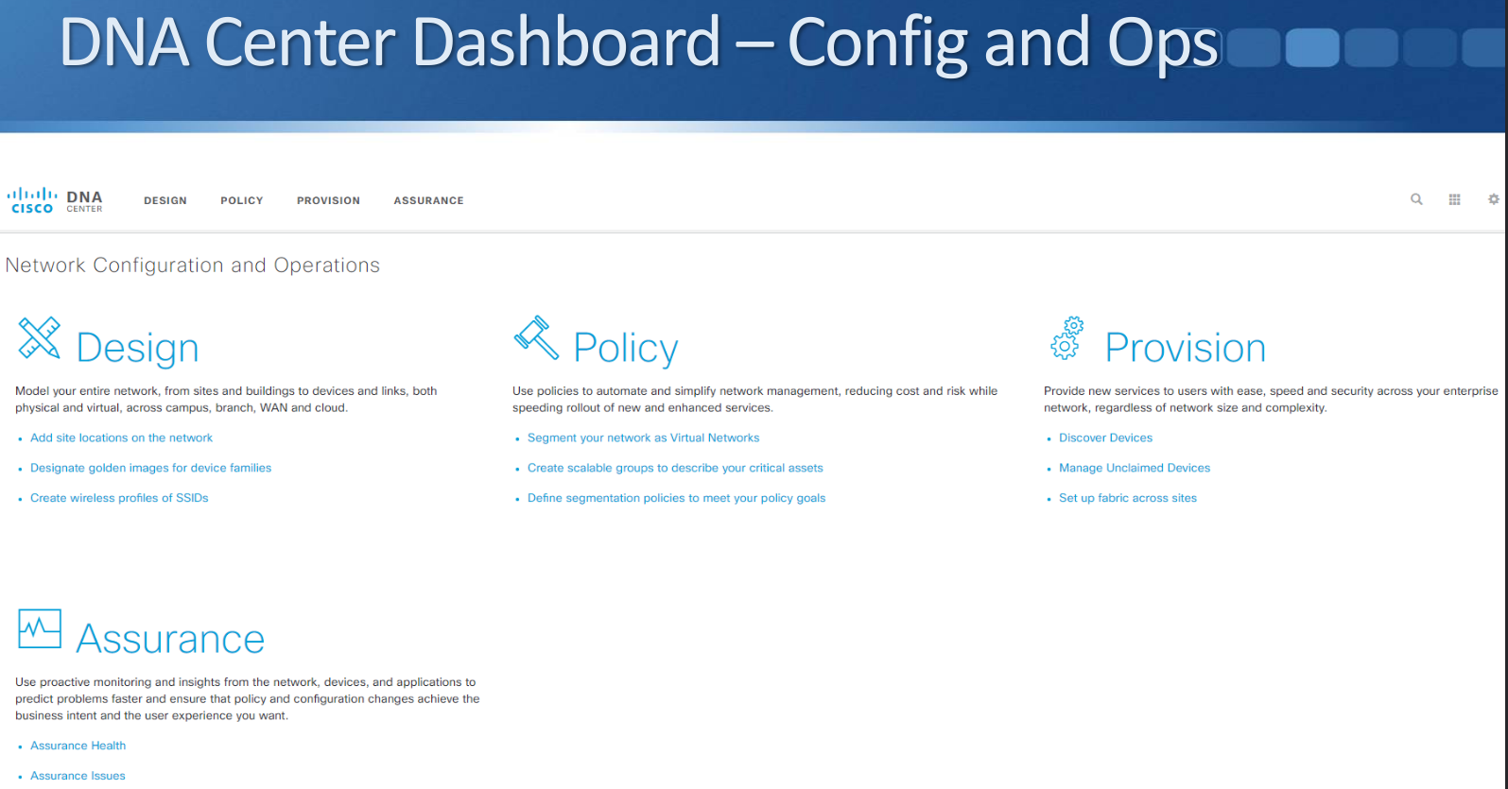

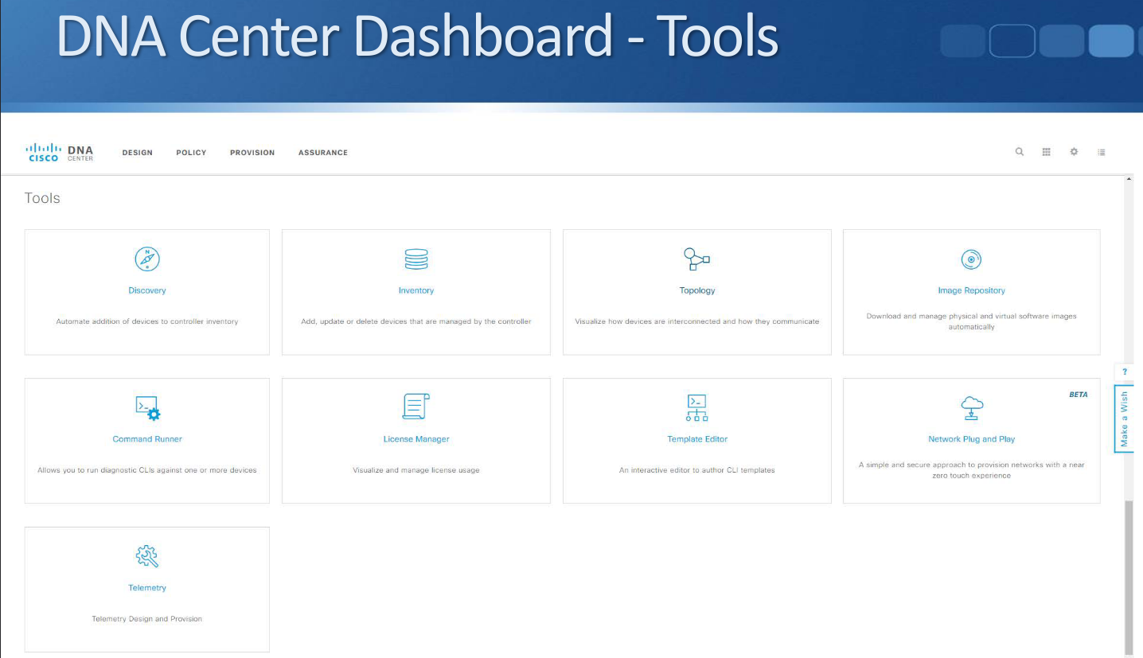

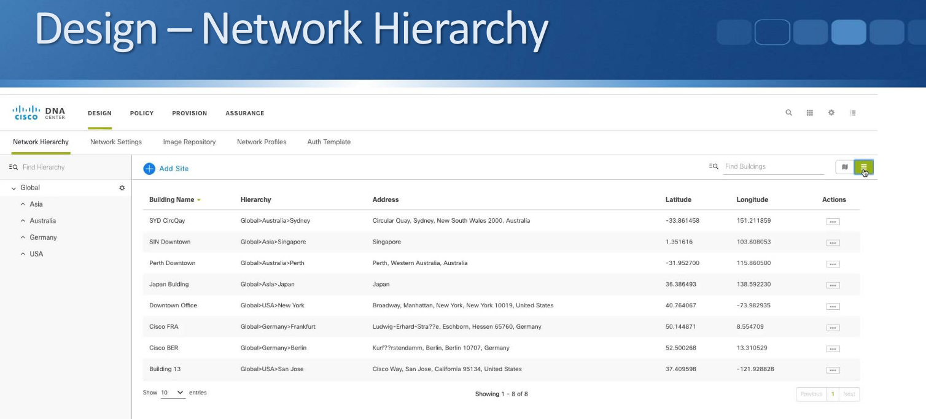

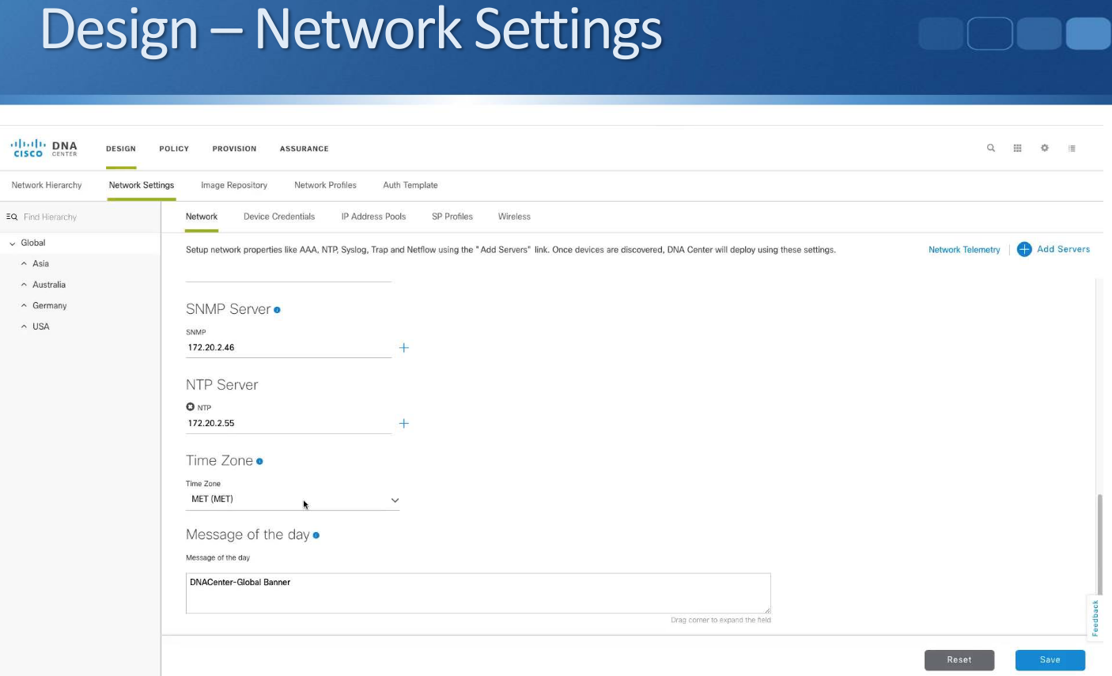

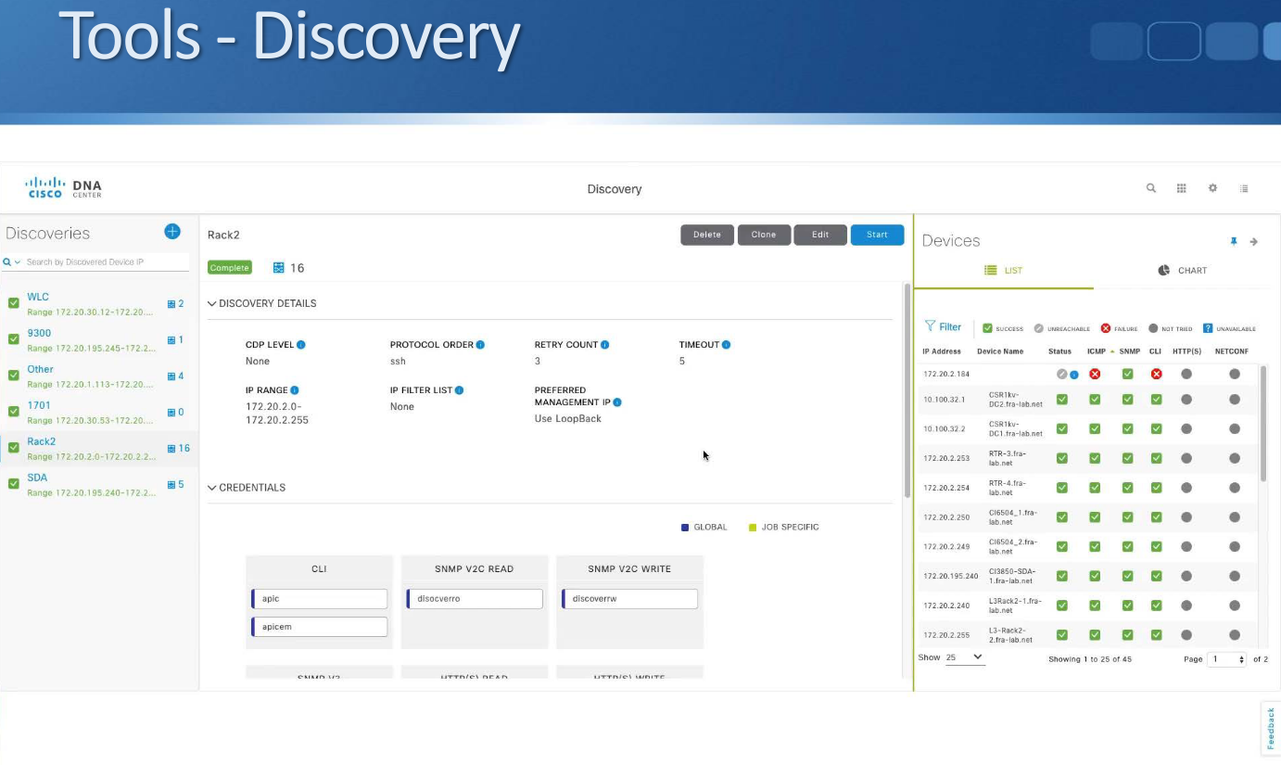

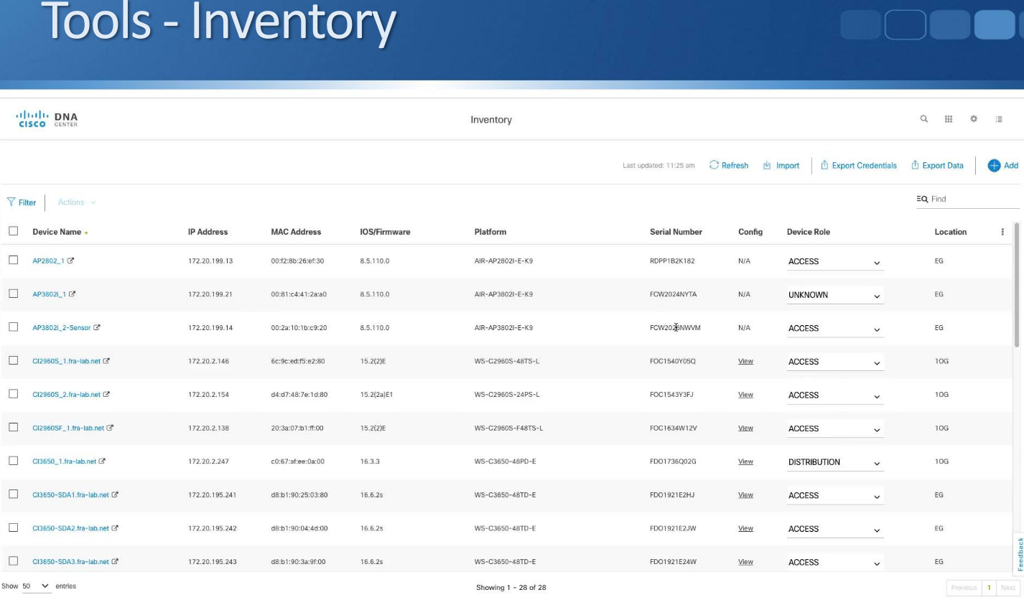

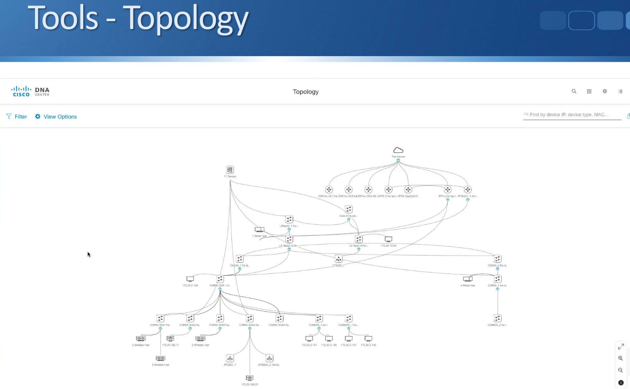

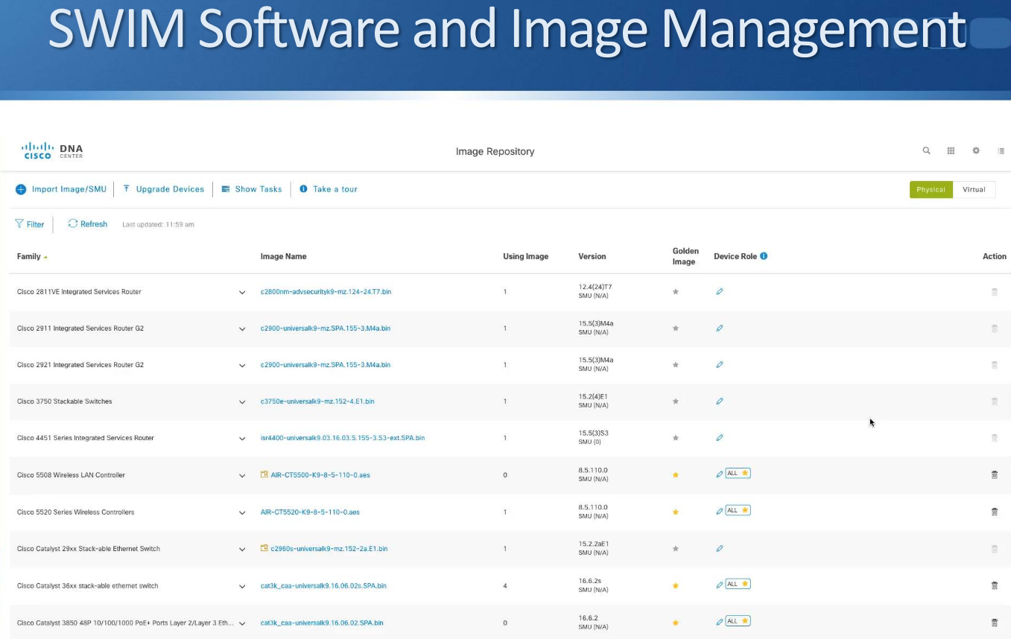

## **SD-Access Software Defined Access**

* SD-Access is a newer method of network access control which solves the limitations of the traditional implementation
* Traffic flow security is based on user identity, not physical location and IP address
* Users log in from and can move to any physical location in the network
* Two components are required for SD-Access:
* Users are authenticated by the ISE Identity Services Engine
* The security policy (permitted and denied communication between groups) is configured on the DNA Center

Underlay and Overlay Network

* SD-Access uses an underlay and overlay network
* An underlay network is the underlying physical network. It provides the underlying physical connections which the overlay network is built on top of.
* An overlay network is a logical topology used to virtually connect devices. It is built over the physical underlay network.
* The combination of underlay and overlay forms the SD-Access ‘network fabric’

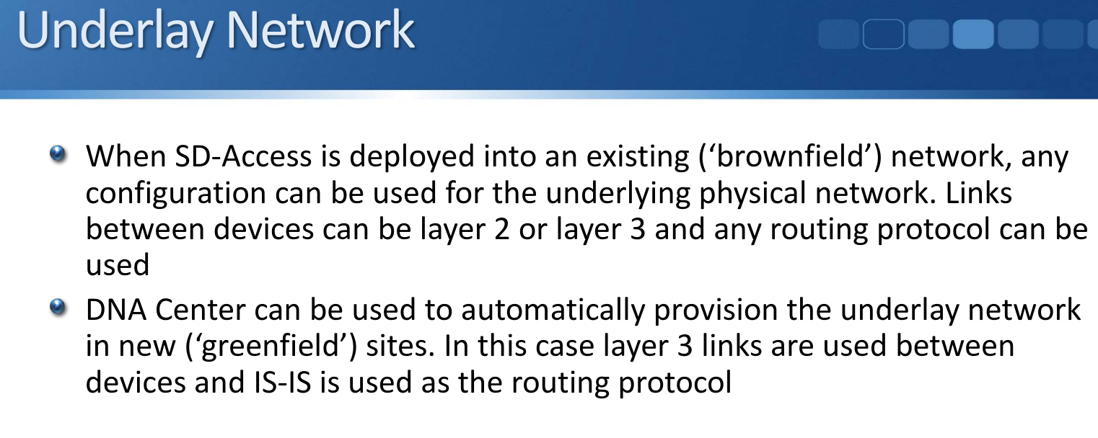

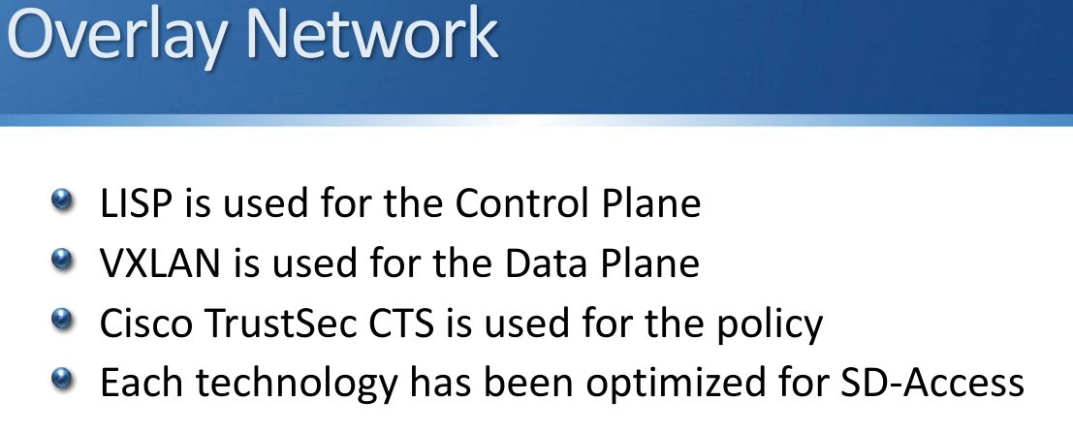

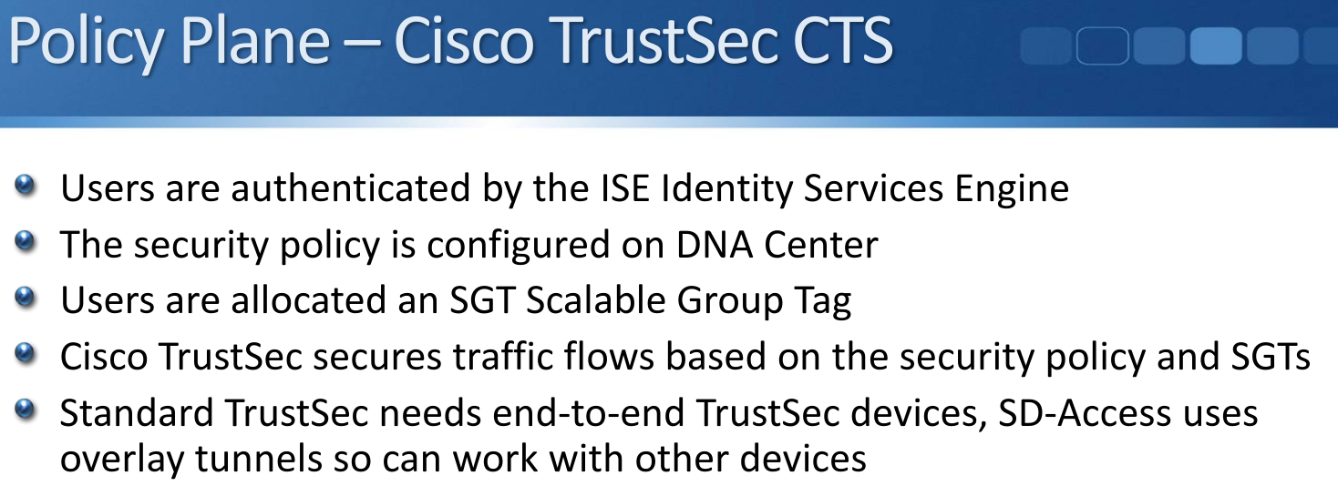

## **SD-WAN**

* Cisco acquired Viptela in 2017 to enhance their SD-WAN solution (previously called ‘IWAN’)
* It provides automated setup of WAN connectivity between sites
* Monitoring and failover is automated
* Traffic flow control is application aware

SD-WAN Benefits

* Automated, standardized setup of connectivity between sites
* Transport independent
* Simplified, integrated operations
* More flexibility and easier to migrate WAN services
* The required, predictable performance for important applications
* Integration with the latest cloud and network technologies
* Lower cost

